NC HEALTHCONNEX CLINICAL PORTAL

NC*NOTIFY   
QUICK REFERENCE GUIDE



­­­

**NORTH CAROLINA**

**HEALTH INFORMATION EXCHANGE AUTHORITY**

# Contents

ACCESSING NC*NOTIFY IN THE NC HEALTHCONNEX CLINICAL PORTAL 3

Viewing Notifications 3

Learn More About Each Feature 4

Logging Out 6

UPLOADING A PATIENT PANEL IN NC HEALTHCONNEX CLINICAL PORTAL 7

What Is the Self-Service Panel Loader? 7

CREATING FILTERS IN THE NC*NOTIFY DASHBOARD 13

Basic View 13

VIEWING NOTIFICATIONS FROM SAVED FILTERS 18

QUESTIONS 19

# I. ACCESSING NC*NOTIFY IN THE NC HEALTHCONNEX CLINICAL PORTAL

Full participants who have enrolled in the NC*Notify V4 or V4+ service will find the NC*Notify event notification and care coordination tool within the NC HealthConnex Clinical Portal. This tool will provide participants with a dashboard-like view of patient activity through event notifications. See below for more details about how to access NC*Notify event notifications.

*Note: Patient data in this guide is from our demo environment. No real patient data is displayed.*

*Note: Cookies must be enabled within the browser to view notifications.*

## Viewing Notifications

Log in to the NC HealthConnex Clinical Portal at <https://portal.nchealthconnex.net> using your assigned credentials.

First, agree to the legal disclaimer to continue.

Next, close the Patient Search window that opens automatically.

To conduct a search or find a list of your organization’s notifications, click the NC*Notify menu item (bell icon) on the left side of your screen.

The user is presented with the following options, View Notifications (eyeball icon) or Upload Panel (upload icon). Click on the eyeball icon.

If you are not a NC*Notify subscriber, the screen below will appear with directions on how to enroll and an overview of the NC*Notify service.



If you have been granted access to NC*Notify notifications via the Clinical Portal, the screen below will appear. The screenshot shown provides a brief overview of each section.

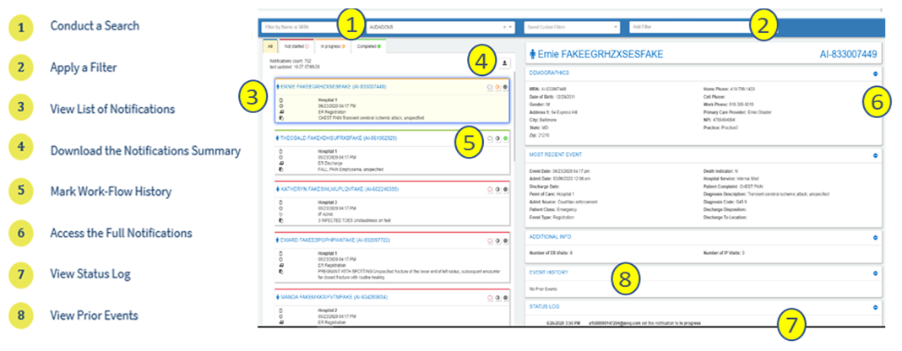

## Learn More About Each Feature

### A picture containing drawing Description automatically generated Conduct a Search

A user can use the search box to filter results by patient name or Medical Record Number (MRN) or Patient ID. The Patient ID or MRN is pulled from the patient panel submitted by the Participant. If a user prefers to search for the MRN of the source facility (i.e., where the event took place), he/she can use the Add Filters drop-down and apply a filter for Source MRN.

### Apply a Filter

There are a variety of filter options that can be used to improve the view of notifications. First, if a user has access to more than one participant’s notification panels (i.e., if he/she has submitted more than one patient panel), he/she can click the Participant drop-down to see notifications from a single panel or all panels combined. Additionally, a user can filter by specific data elements in the notification using the Add Filters drop-down (e.g., number of ER Visits, Diagnosis, Chief Complaint, PCP, Event Type). This feature allows the user to apply specific search criteria to the notifications view. For example, a user could search for frequent ED utilizers with filters for Patient Class = Emergency (E), Event Type = Discharge (A03), and Number of ER visits.

### View List of Notifications

The notifications preview provides a quick summary of the following items:

* Gender
* Name
* MRN/Unique identifier assigned by you (the participant)
* Location, date and time of the encounter/event
* Notification event type
* Patient complaint followed by the diagnosis (if provided)

### Download the Notifications Summary

One of the buttons in the upper right corner of the notifications preview section is the download button. This allows you to download all notifications or a list of notifications that have been selectively filtered (up to a maximum of 500 notifications). The downloaded notifications are saved as a comma-separated file (.csv), which will open in Microsoft Excel. This feature allows the user to download notifications at any time based on his/her selected criteria and share data with outside users or care teams, add additional data to the spreadsheet, and more.

### View Workflow Status

The NC*Notify dashboard within the Clinical Portal has three basic work-flow statuses (Not started, In progress, and Completed) to allow users to track actions taken during care coordination. Each status corresponds to the respective tab in the notifications preview screen and will also be recorded in the Status Log section of the full notification view.

### Access the Full Notification

When a notification is selected from the list, a more detailed view will display on the right with information from both the ADT (admission, discharge, transfer) message and the patient panel submitted by the Participant. This includes key demographic and event information including, but not limited to:

* Name
* Patient ID or MRN
* Date of Birth
* Address
* Number of IP and ER Visits (last 6 months)
* Recorded Event Date and Time
* Patient Class (e.g., ER, IP, OP)
* Event Type (e.g., Admit, Discharge)
* Event Location
* Patient Diagnosis
* Discharge Disposition
* Discharge Location
* Patient Complaint
* Admit Source

### View Status Log

A Status Log section is displayed below the Most Recent Event and/or Additional Information sections of the detailed notification view. This section provides a history of actions taken by users when changing the status. Each entry will record the username, date and time, and which work-flow status was set for the notification.

### View Prior Events

At the bottom of the detailed notification view, the event notification service also displays a list of historical events for the patient. The Event History begins when the Participant goes live on NC*Notify (when the first patient panel/roster was submitted). Each prior event is populated by information from the Admission Discharge Transfer (ADT) messages that are received.

## Logging Out

To log out of NC*Notify and the clinical portal, click the user name at the top right of the screen, and then click the logout menu item from the dropdown menu. Now close the browser tab.

*Note: NC*Notify sits inside of the NC HealthConnex Clinical Portal which automatically times users out after 15 minutes of inactivity. This can cause NC*Notify users to time out unexpectedly if they are not actively engaged with a Clinical Portal window.*

# II. UPLOADING A PATIENT PANEL IN THE CLINICAL PORTAL

## What Is the Self-Service Panel Loader?

The Self-Service Panel Loader (SSPL) is a panel management tool available to a user who is assigned the %HS_NCNotify_SSPL role. SSPL provides an easy, fast, and convenient method for submitting panels for practices. User will also receive an immediate response when panels are loaded successfully or incorrectly.

### Step 1

* Click the NC*Notify menu item (bell icon) on the left side of the screen.
* Click “**Upload Panel”** (upload icon).

On the default screen you will see your panel activity feed.

The left-hand side of the screen will show you the status of your panel, whether it was successfully loaded or not.

To proceed with uploading your panel, click the check box (By proceeding, I understand that I will overwrite my panel) and click “**Continue**.”

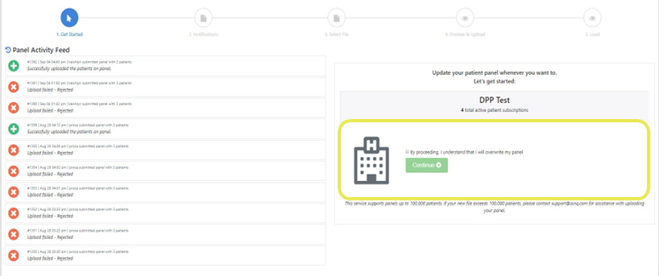

### Step 2

Push Notifications: Turn on the email or text notification to be notified once panel loading is completed.

Enter the email or phone number that will be used. Then click on “**Upload File**” to attach panel.

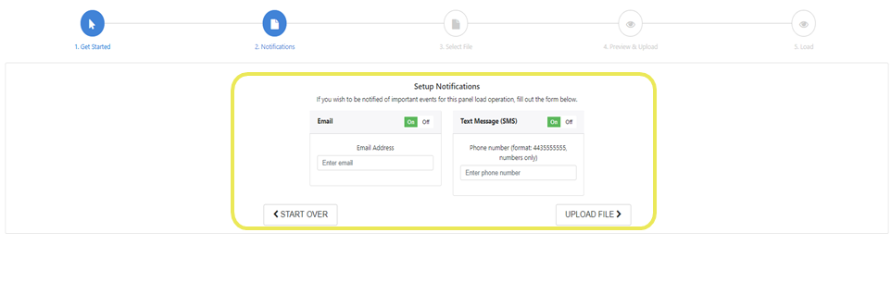

### Step 3

Patient Panel Template: If you need the most updated Patient Panel Template, click the “**Download Template File**” Link to download a panel template.

To prevent panels from failing when being loaded, ensure that all required fields are populated:

* MRN
* First Name
* Last Name
  + Note: _ or $ are useable, but ascii characters or blank patient id are not valid
* Address 1
* City
* State
* Zip
* Birth Date (MM/DD/YYYY)
* Gender

Ensure all information is in the right format:

* Click “View Formatting Information link” for each field

More details on the file naming structure will be provided by our technical team during onboarding.

* Example: ENS_TEST-1-z-09-23-2019

File must be saved as:

* .CSV prior to uploading

### Step 4

After attaching the file, the system will give you a preview of the rows to be loaded. Review the fields to ensure the headings match the data. It will also show the number of new patients that will replace your current patient panel and the correct naming convention.

Then click on “**Upload New File**.”

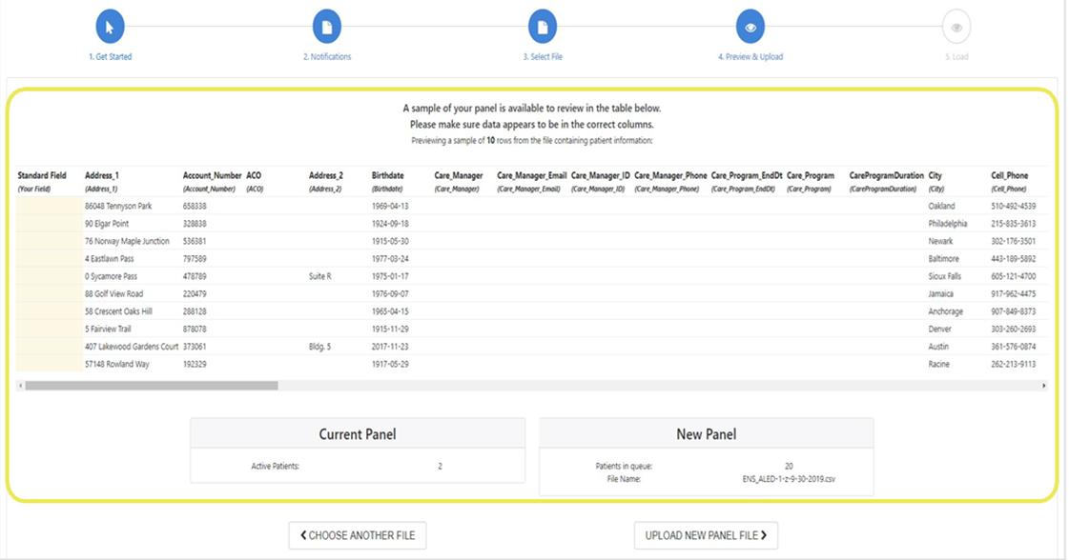

### Step 5

A status bar will appear showing the progress of the upload. Once the panel is loaded successfully, the “Roster File Upload Complete” notification will appear. Click the close button to proceed.

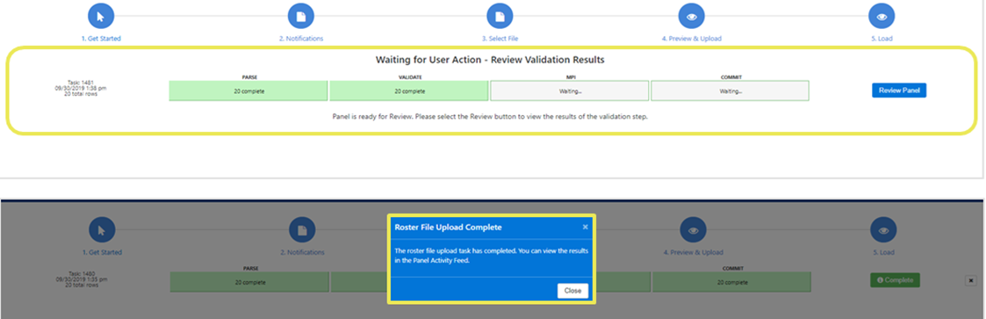

|  |  |
| --- | --- |
| **Panel Size** | **Average Upload Time** |
| 80–120 patients | 8 minutes |
| 900–1,100 patients | 18 minutes |
| 7,000–14,000 patients | 25 minutes |
| 95,000–105,000 patients | 1 hour 27 minutes |

### Step 6

Review Panel: Some panels may require additional review prior to upload completion. To review, click the “**Review Panel**” button.

The review button will show the number of rows that must be reviewed.

### Step 7

Click the “**View Row Report**” button then select the download link to view specifics rows within the panel that requires additional review.

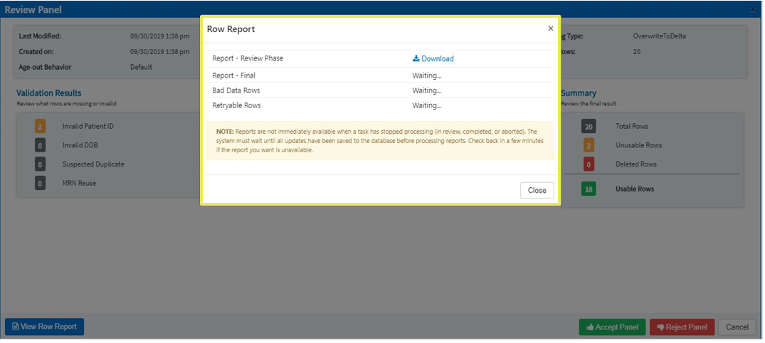

### Step 8

After reviewing the report, select the thumbs up button to accept or the thumbs down button to reject the panel.

Accepting the Panel = Panel will be uploaded without the rows with the errors.

Rejecting the Panel/Cancel = Upload task will be cancelled, allowing user to make corrections before re-uploading.

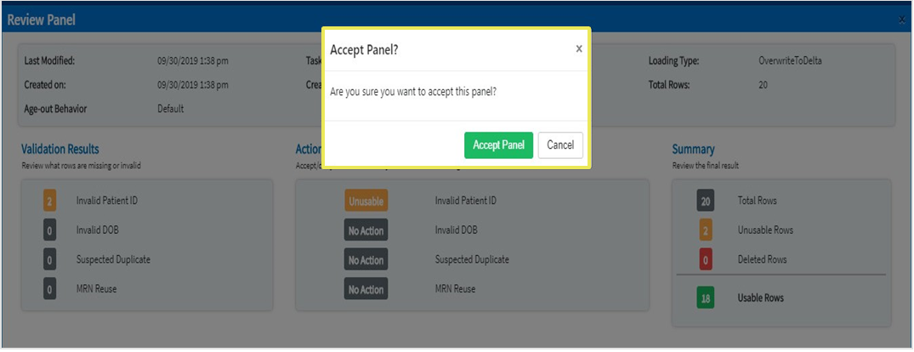

### Step 9

If a panel fails after the review and loading stage:

1. Go to the Panel Activity Feed.
2. Find the panel fail notification.
3. Click on the X button on the notification.
4. Review rows and failure reasons by clicking on the View Row Error Report button.

Common reasons why panels fail:

* File is not saved as .CSV format
* Headers/Column Names in Patient Panel Tablet have been altered.
* Download a patient panel template and use as is.
* Review rows and failure reasons by clicking on the View Row Error Report button
* File naming convention is incorrect

### Step 10

Confirmation: Our system will send a confirmation email or text to user after every successful upload if a user has entered their information in step 2.

# III. CREATING FILTERS IN THE NC*NOTIFY DASHBOARD

## Basic View

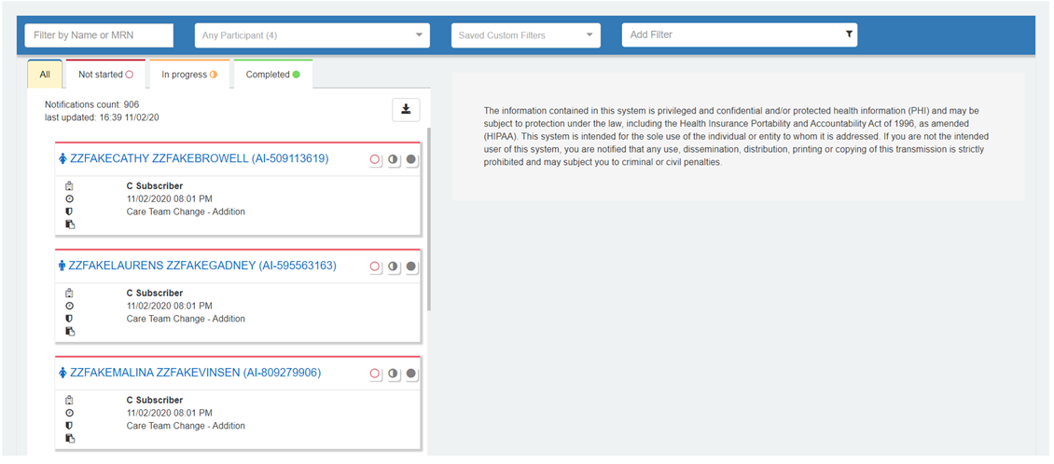

### Step 1

Select the drop down titled "Add Filter":

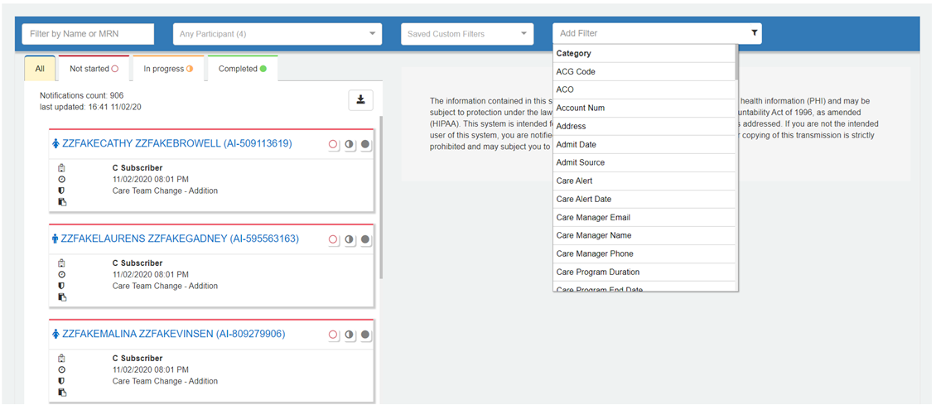

### Filter Options

|  |  |  |  |  |
| --- | --- | --- | --- | --- |
| **Options** | | | | |
| Account Num | Cell Phone | Discharge to Location | Last Name | Patient Complaint Code |
| Address | City | Event Date | Location | Patient Identified Provider ID |
| Admit Date | Consulting Provider Name | Event Facility | MRN | Patient Identified Provider Name |
| Admit Source | Date of Birth | Event Type | Middle Name | Practice Name |
| Admitting Provider ID | Death Indicator | Facility | Number of ER Visits | Referring Provider ID |
| Admitting Provider Name | Department | First Name | Number of IP Visits | Referring Provider Name |
| Alert Note 1 | Diagnosis Code | Full Name | Observation Status | Source MRN |
| Alert Type | Diagnosis Description | Gender | Organization | State |
| Attending Provider ID | Discharge Date | Home Phone | Patient Class | Work Phone |
| Attending Provider Name | Discharge Disposition | Hospital Service | Patient Complaint | Zip Code |

### Step 2

This example is searching for any patient that presented with COVID or COVID symptoms.

* Select a filter (Patient Complaint).
* Once selected, choose a category from the pop-up box (Contains).

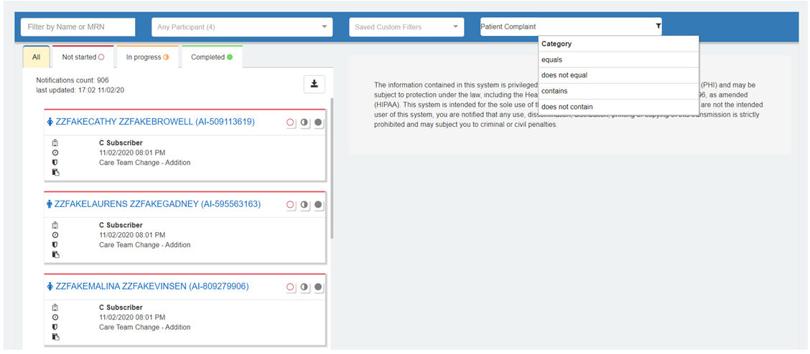

### Step 3

* Type the name of virus (COVID) or COVID symptom.
* Press Enter.

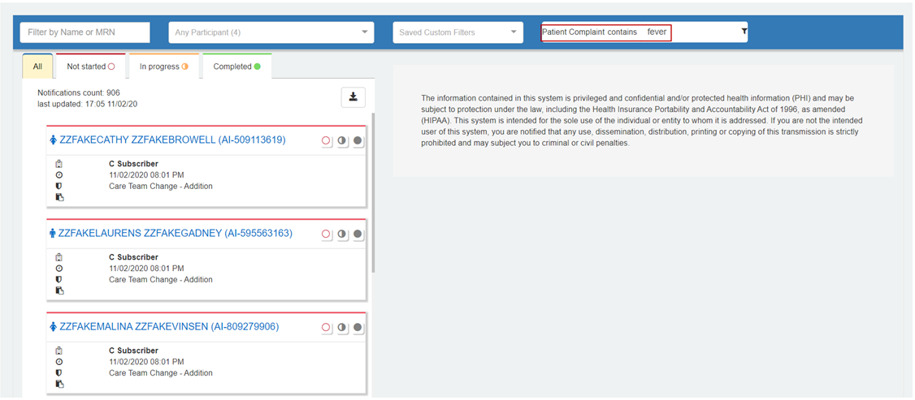

### Step 4

The only Notifications displayed will be patients who presented with "COVID" and/or "Fever" as their chief complaint.

*\** Filter can contain multiple filters as shown below (treated as "Or").

*The notification with fever as the complaint is not related to COVID.

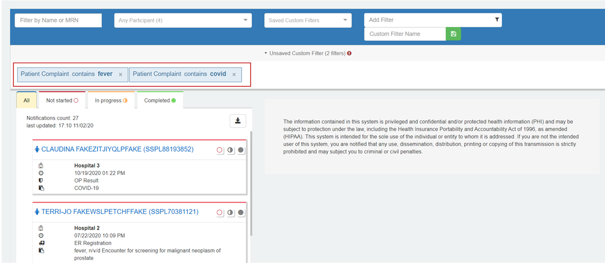

### Step 5

To save the filter, enter a filter name in the box labeled "Custom Filter Name":

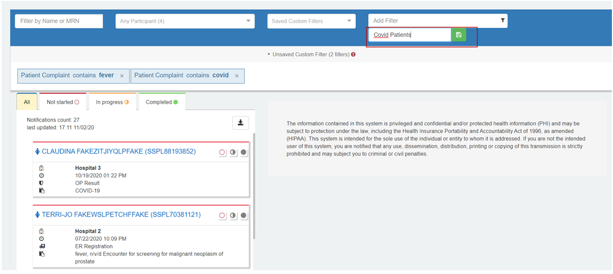

### Step 6

Select the green "Save" button to the right of the text and the saved filter name is available from the ‘Saved Custom Filters’ button.

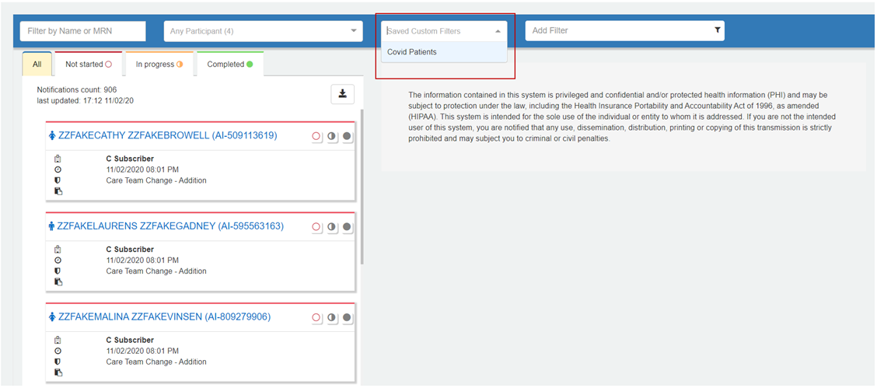

# IV. VIEWING NOTIFICATIONS FROM SAVED FILTERS

### Step 1

Select the filter from the pull-down menu to apply the filter:

* *Custom filters may be saved and are available in the pulldown "Saved Custom Filters" menu.*

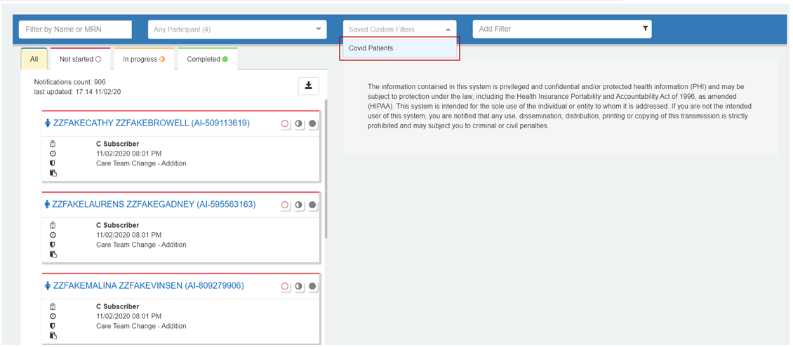

### Step 2

After selecting a filter, the "Trash Can" icon may be used to delete/remove the filter:

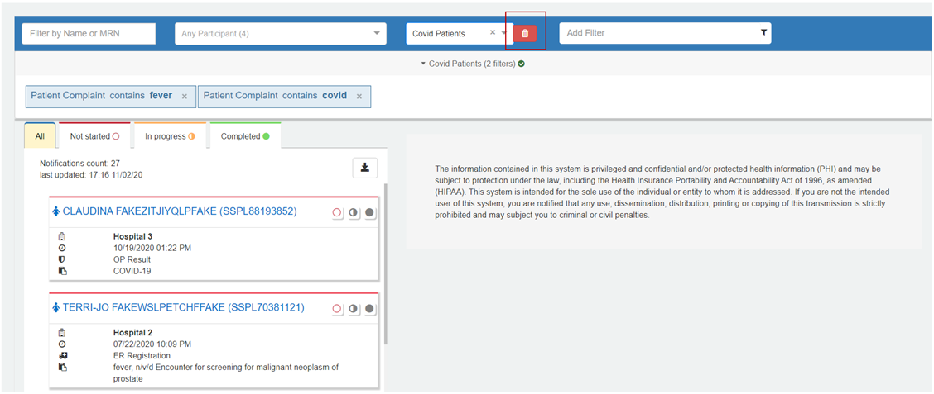

### Step 3

To alter a filter, the filter can be removed and re-saved. To re-save, begin at step 1 under the Creating Filters in the NC*Notify Dashboard section.

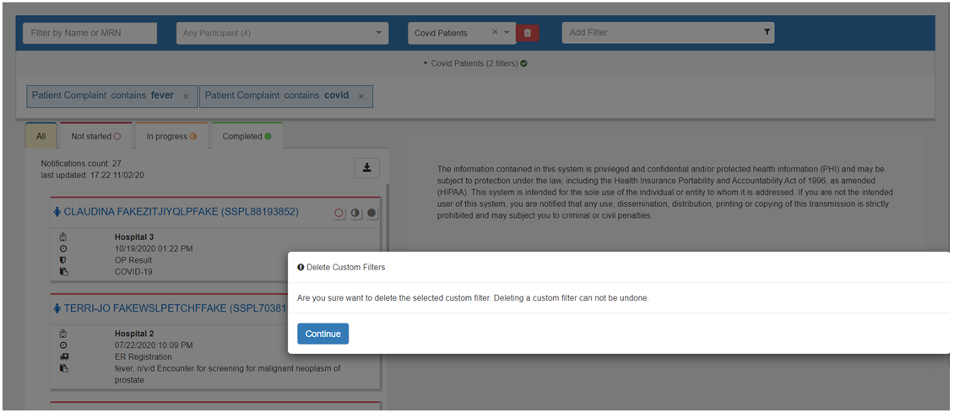

# V. ADDITIONAL FILTER EXAMPLE - Discharges For the Previous Two Days

# Providers often need to see their discharges for the previous two days for transitional care management under Medicare. This example will show you how to create this filter.

### Step 1

Select the drop down titled "Add Filter" and then select “Event Type.” And then select “equals.”

### Step 2

### Select “A03: DISCHARGE” from the drop down menu.

### Step 3

Select the drop down titled "Add Filter" and then select “Event Date.”

### Step 4

Select “>=” (greater than or equal to) from the drop down menu.

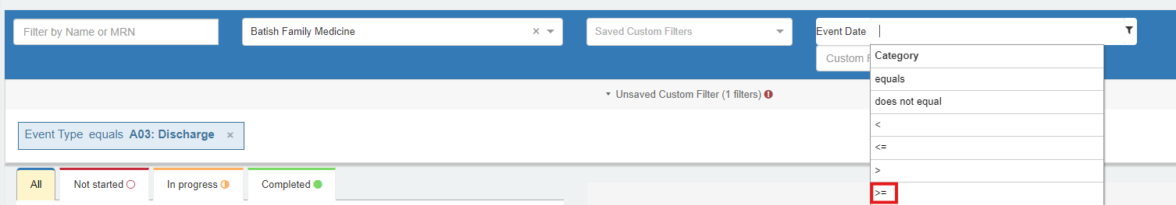

### Step 5

Today’s date will be highlighted in blue. Select the date from two days ago.

Your filter should be displayed like this:

# QUESTIONS

* Access the [NC HealthConnex Clinical Portal](https://portal.nchealthconnex.net/).
* The full NC HealthConnex Clinical Portal User Guide is available at <https://hiea.nc.gov/documents/nc-hiea-primary-provider-user-guide>.
* For additional assistance, please contact the Help Desk by emailing [HIESupport@sas.com](mailto:HIESupport@sas.com) or call 919-531-2700.